Christian Rowsell

UBC Mechanical Engineering – Fall 2022

Mech 587 Project 3

Navier-Stokes Solution using SIMPLE Method

Programming Assignment – 3

In this assignment, your final objective is to numerically solve the Navier-Stokes equation with **S**emi-**I**mplicit **M**ethod for **P**ressure **L**inked **E**quations (SIMPLE), and verify your code with the lid-driven cavity problem. The Navier-Stokes equations for the time interval (0*,T*) in a domain Ω is given by,

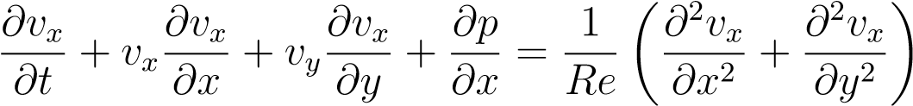 in (0*,T*) × Ω*,* (1)

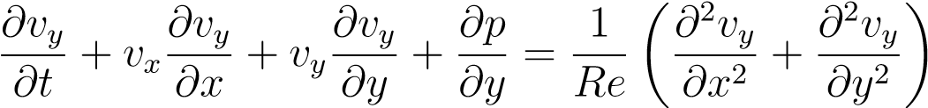 in (0*,T*) × Ω*,* (2)

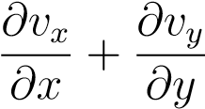= 0 in (0*,T*) × Ω*,* (3)

|  |  |  |
| --- | --- | --- |
| *v*(*x,y,*0) = *v*0*,* | *p*(*x,y,*0) = *p*0 | (4) |
| *v*(*x,y,t*) = *vD* | on *∂*Ω*D,* | (5) |

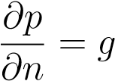 on *∂*Ω*N,* (6)

where *∂*Ω*D* and *∂*Ω*N* denote the regions of the boundary over which Dirichlet and Neumann boundary conditions are applied respectively. *v* = (*vx,vy*) and *p* denote the velocity and pressure field over the domain Ω.

# Preparation

The implementation of the Navier-Stokes solver with SIMPLE method can be decomposed into the following steps (There are 40% marks towards these steps! You need to write them together so that you can modify your file toward the Navier-Stokes solver later):

1. 2D advection-diffusion equations Solve the following equations:

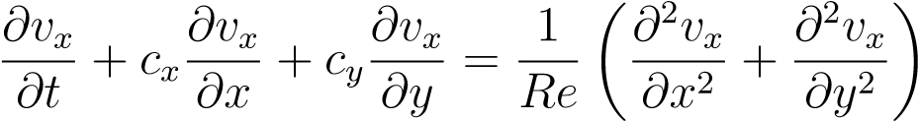 in (0*,T*) × Ω*,*

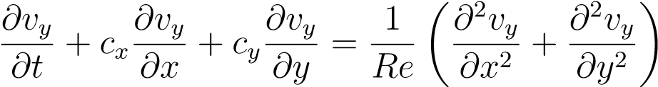 in (0*,T*) × Ω*,* • For the spatial discretization, discretize the convective and diffusive terms using the 2*nd* order central differencing scheme

* For the time integration, Use (a) Adams Bashforth method for the convective terms and (b) Trapezoidal method for the diffusive terms.

Check your code with the second problem in project 2. Run the code at any of three grids with difference level of refinement. Report ||*vx* − *ϕe*||2 and ||*vy* − *ϕe*||2, where *ϕe* is the exact solution in project 2. Report the order of convergence. Save the code for your own reference.

Project 2 code was modified so that it can solve both the X and Y momentum equations simultaneously.

|  |  |  |
| --- | --- | --- |
| Grid Size | L2Norm | |
| ||*vx* − *ϕe*||2 | ||*vy* − *ϕe*||2 |
| 17x17 (289 grid points) | 2.558504873729e-02 | 2.55850487372923e-02 |
| 33x33 (1089 grid points) | 6.321108496806e-03 | 6.32110849680624e-03 |
| 65x65 (4225 grid points) | 1.569247085119e-03 | 1.56924708511860e-03 |

2. Include the pressure gradient

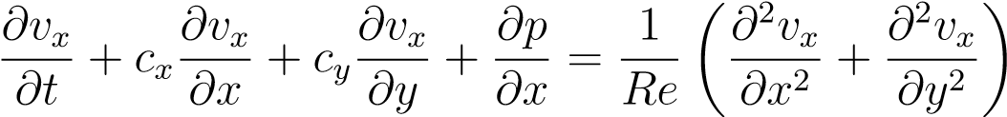 in (0*,T*) × Ω*,*

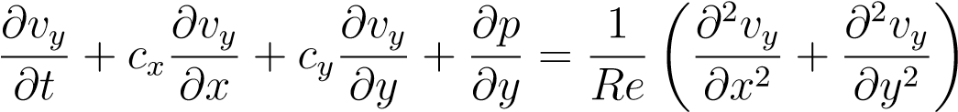 in (0*,T*) × Ω*,*

* Write a function which takes *p* and give *∂p/∂x* and *∂p/∂y* for the interior nodes.
* Use the 2*nd* order central difference scheme for spatial discretization

Given *p* = *x*, check the vector *∂p/∂x*. Similarly, given *p* = *y*, check the vector *∂p/∂y*. Report the calculated value at one of your interior grid point.

3. Pressure correction equation

Solve the following equation:

∆*p* = *s*

where *s* is a vector of source term

• The Laplacian operator is discretized with the 2*nd* order central difference method.

Check the solver with the problem 1 in the project 1. Solve for three grids with different level of refinement. Report the *L*2 norm of the error and the order of convergence.

# Navier-Stokes solver with SIMPLE method

Adjust the prepared code towards the Navier-Stokes solver with SIMPLE method (see project description).

# Verification with the cavity problem

The lid-driven cavity problem is a widely used test case for benchmarking incompressible flow code. Then fluid contained inside a squared cavity is set into motion by the upper wall, which is sliding at a constant speed (see Fig. 1). Take the the sliding velocity as *U* = 1, density of the incompressible fluid to be *ρ* = 1 and the dynamic viscosity to be *µ* = 0*.*01.

1. Start by using 33 by 33 grid so that you have nodes located at the centerline of the cavity at *x* = 0*.*5 and *y* = 0*.*5. Run the simulation until steady state. Bisecting the length of the intervals until 129 by 129.

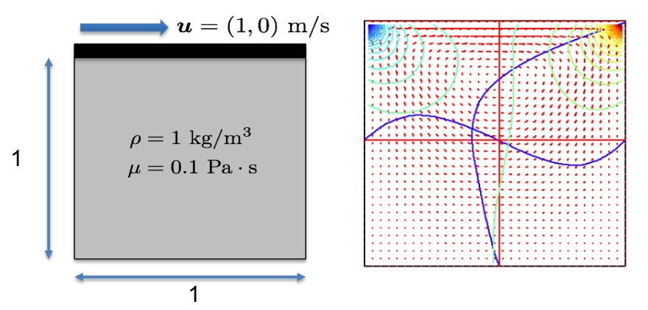

Figure 1: Cavity problem: definition of the problem (left) and demonstration of the solution with pressure contour and velocity at mid-lines (right)

1. Plot the velocity at the centerline against the TABLE I and TABLE II in reference [1] at different grid sides.
2. Report the spatial convergence of the velocity and pressure field.

# References

[1] UKNG Ghia, Kirti N Ghia, and CT Shin. High-Re solutions for incompressible flow using the Navier-Stokes equations and a multigrid method. *Journal of Computational Physics*, 48(3):387–411, 1982.